**Automatic Arm Warmer**

ECE4781 Biomedical Instrumentation

Georgia Institute of Technology

Team Members:

Samuel Ruiperez Campilo, sruiperez3@gatech.edu (3)

Joseph Doughty, jdoughty3@gatech.edu (3)

Anand Dugad, ananddugad@gatech.edu (3)

Jae Hyun Kim, jae31@gatech.edu (3)

Samruddhi Kulkarni, sskulk307@gatech.edu (3)

Submitted  
December 4th, 2018

**Executive Summary**

Though there are myriad preventative guidelines to be found for people who work in below freezing temperatures, there are relatively few actual solutions to be found. Research has shown that repeated exposure to cold environments over time can lead to long-term health problems such as being more susceptible to cold-related health issues, particularly hypothermia and frostbite. Additionally, the cold causes shivering of the arms which may cause people to have difficulty performing tasks with handheld tools, decreasing their work efficiency.

A prototype of a solution has been created in the form of an armband which uses a battery-powered system of a microcontroller and three sensors to automatically detect the combination of shivering of the arm, low ambient temperature, and muscle signals relating to the wearer’s fingers being closed as an object is gripped. Upon detecting that all three of these conditions are occurring simultaneously, the armband will activate an internal heating pad for five minutes which will warm the wearer’s forearm, reducing shivering and enabling the user to perform their work with increased arm stability while also decreasing the long-term negative effects of working in cold environments.

**Introduction and Significance**

People who work outdoors may be exposed to extreme climates ranging from scorching heat to freezing cold. Because of this, countries such as the United States of America and Canada have regulatory protocols for managing labor situations involving such difficult work situations, though they often entail preventative guidelines rather than providing actual solutions [1, 2]. Studies conducted in cold places – such as those performed by Dr. Yutaka Tochihara – have indicated that people who repeatedly work in the cold may have a higher likelihood of experiencing hypothermia and fatal accidents [3].

According to Dr. Tochihara’s controlled experiments, working in a cold environment may lead to a broad range of long-term negative effects including the onset of cold-stress and a decrease in the ability to perform manual labor [4]. Similarly, a field study by F. Chen, et al. on 436 cold store workers in China showed that many of them had higher lower back and knee pain compared to a control group, as well as frostbite of the extremities [5]. These effects have been tested in animals in hopes of finding explanations for the physiological changes that are detected after exposure to such environments, parameters of the cold-stress response, and the consequences of repeated exposure [6]. Additionally, studies have been carried out to understand the impact of extreme temperatures on neuromuscular function [7]. Aside from potential negative effects on the health of a person who is working in the cold, the research of Ken Parsons has shown highly diminished efficiency of workers, especially in labor involving handheld tools [8].

One of the main causes of the decrease in dexterity for such workers is shivering, a bodily response to lowered body temperature which involves rapid involuntary muscle contraction and relaxation [9]. Shivering of the arms may make it difficult for a worker to adequately perform tasks with handheld tools, but wearing more layers of protective clothing can also impede the wearer by constricting their movement or reducing their ability to pick up and manipulate objects.

No extensive studies were found that intend to overcome these difficulties and improve the efficiency of people who must work for extended periods of time in the cold. There have been some products marketed towards such workers, such as the Volt Work Gloves, which are a pair of gloves each containing a battery-operated heating pad that must be manually activated by the user [10]. The fact that this product requires the user to turn it on may pose a problem considering the loss of sensitivity (including to temperature) that occurs when critical cold-stress is reached [11].

For this reason, a solution was proposed based on a novel concept of an armband containing a heating pad which is automatically activated based on several physiological or environmental conditions occurring at the same time. Theoretically, a worker who uses this device would experience decreased cold-stress and increased efficiency in manual labor tasks involving handheld objects. The parameters considered for activating the heating pad in the prototype of the device are low ambient temperature, shivering of the arm, and electromyographical (EMG) signals relating to muscle contractions responsible for finger flexion.

The low ambient temperature condition threshold was set to be 0°C because of research on convective cold exposure on skin temperature over time carried out by F. Chen, et al. which found effects such as cold induced vasodilation occurring as soon as five minutes [12]. The threshold relating to shivering was set to a frequency of eight to ten hertz, a range which is constant for most people according to studies conducted in artificial cold environments designed specifically to induce shivering [13]. This range is consistently accurate because shivering is a common reflex that occurs when the body detects a significant or lethal decrease in body temperature. This reflex is caused by delaying rates of heat loss via peripheral vasoconstriction and by increasing rates of heat production via a process called shivering thermogenesis [14].

Finally, the threshold relating to muscle activity for finger flexion is dependent upon the sensor used and the output level it produces. For this prototype, the MyoWare Muscle Sensor was selected, which outputs a filtered, rectified, and amplified voltage level based on the amplitude of the EMG signals sensed in the muscle(s) the sensors electrodes are placed near [15]. These electrodes are positioned in the armband to measure the EMG signals in the primary muscle responsible for finger flexion, as this is the action of interest for this device. The voltage threshold was set to be half of the maximum output voltage of the EMG sensor – this value was selected based on experiments the team performed while attempting to imitate real use cases while using the EMG sensor.

**Project Narrative**

To best serve the intended purpose of the device - lowering cold-stress while raising effectiveness of workers in below freezing environments - the electronic components of the prototype were selected based on the qualities of high accuracy, requiring low amounts of power, and having a small form factor in order to minimize impeding the wearer from carrying out their tasks. A block diagram of the device is shown in Figure 1, and a photo of a demonstrated prototype of the armband is shown in Figure 2.

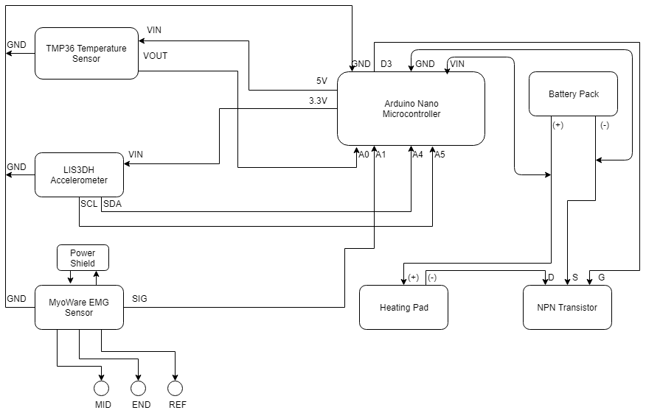

Figure 1. Block diagram of the electronic system in the armband.

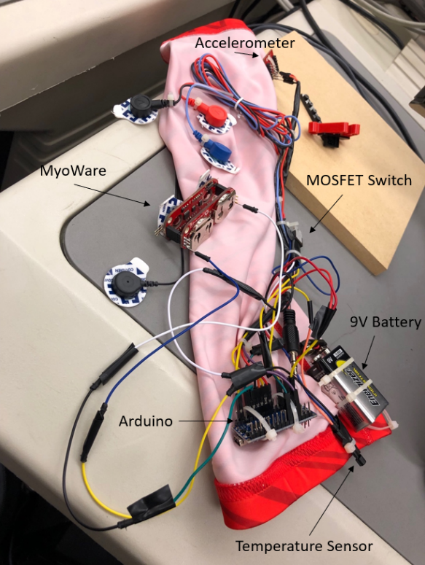

Figure 2. Photo of a prototype of the armband.

Management of all input and output signals is performed by an Arduino Nano microcontroller. The Nano’s small size (18mm x 45mm), low power consumption (19mA), and ability to be powered with a battery pack makes it ideal for this application [16]. A program was written for the Arduino which monitors the input from each of the three sensors and checks every half second to see if each surpass a certain measurement threshold, which makes a Boolean representing the condition relating to the threshold “true” (otherwise, the Boolean is “false”). If the input from all three sensors meet their conditions (all three Boolean values are “true”) at the same time, then the Arduino outputs a signal which turns on a heating pad contained in the armband for five minutes – otherwise, the heating pad is turned off. After each sensor is introduced below, the use of that sensor’s signal and the related condition will be explained. The final version of the Arduino program used can be found in Appendix I with comments where necessary.

Ambient temperature is measured with a TMP36 Temperature Sensor which has an accuracy of ±2.0°C over its -40°C to +125°C operating range and outputs a voltage with a scale factor of 10mV per °C [17]. The Arduino measures this voltage, converts it to a digital quantity, and uses the scale factor to determine the temperature of the surrounding environment. Next, the algorithm checks to see if the temperature is below a threshold value – again, 0°C for this iteration of the design – and if it is, then the condition of low environmental temperature is set to “true” until the temperature is measured to be above the threshold, at which point the condition is set to “false”. The TMP36 is placed on the armband such that when worn, it will be located near the upper arm of the wearer so that it is able to get a reliable reading without potentially being damaged by normal working procedures or getting temperature interference from warm objects in the environment – such as an engine in a recently used car if the user is a mechanic, for example.

Shivering is detected by a SparkFun LIS3DH Triple Axis Accelerometer, which can detect motion in the x-plane, y-plane, and z-plane [18]. The connection between the accelerometer and the Arduino is made via a Serial Peripheral Interface (SPI) connection due to its simplicity over other options such as I2C. The x and y positions of the accelerometer are compared to the previous values for reading, and if either has changed by at least 10% of the maximum range of the position, then a shake counter variable is incremented by one. If neither position has changed by at least 10% of the maximum, then the counter is decreased by one. This is to reduce false positives which may come about from stillness, small movements, and long fluid motions such as swinging of the arm to reach for an object. Once the shake counter has reached a value of 50, the shiver condition is set to “true” and it will not be incremented past 50. If the shake counter decreases to a value lower than 50, the shiver condition will be set to “false”. Note that a person who is shivering while moving their arm will likely be inducing large changes in both the x and y readings of the accelerometer at the same time – in this case, the shiver condition will become true after 25 loops (12.5 seconds as each loop takes a half second). The accelerometer is housed in the armband such that it will be near the ulnar side of the wearer’s wrist so that it can obtain maximum positional variance and reduce the likelihood of the sensor being damaged or impeding the user’s work.

The armband detects the user is holding something by measuring EMG signals in the extensor digitorum muscle, which was chosen as it as the primary muscle involved in finger flexion [19]. To detect and process the EMG signals, a MyoWare Muscle Sensor kit is used, which filters, rectifies, and amplifies the signals and outputs a voltage from 0V to Vs (supply voltage, in this case 3V) relative to the amplitude of the detected signals [20]. To reduce interference and isolate the EMG sensor, a specialized MyoWare Power Shield is used which takes two CR2032 batteries and supplies 3V to the sensor [21]. A sensor cable with three electrodes (MID, END, and REF) that use biomedical sensor pads is used for further isolation while allowing the relatively large sensor unit to be placed on the upper arm [22, 23]. This cable plugs into a MyoWare Cable Shield which is “stacked” on top of the power shield and sensor unit [24].

Although the flexor digitorum muscle is the primary muscle responsible for finger flexion (closing), it was difficult to get consistent EMG readings with the sensor electrodes due to the muscle being partially covered by the brachioradialis muscle and flexor carpi ulnaris [19]. Therefore, the extensor digitorum was instead chosen as the measuring site for the prototype as many muscles in the surrounding area have a role in conducting hand movements [19]. Position and orientation of the three electrodes is an important determinant of signal strength and quality because of the variance of the number of motor units measured as well as the potential for cross-talk interference [25]. The MID electrode is placed on the middle of the muscle body, the END electrode is aligned with the orientation of the muscle fibers, and the REF electrode is placed in a relatively electrically neutral location such as nearby bone or less active tissue [26]. A hand-drawn diagram of the right arm is shown in Figure 3, with the extensor digitorum highlighted in orange and the ideal location of the MID and END electrodes indicated by a red box.

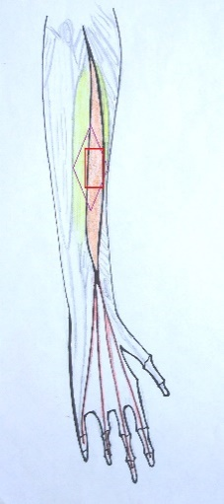

Figure 3. Diagram of the right arm.

The output voltage from the EMG sensor is read into an analog pin on the Arduino and converted to a digital signal via a scale factor. The algorithm checks to see if the signal has passed the threshold value experimentally set at 1.6V (half of the maximum 3.3V), at which point the condition relating to the wearer holding an object is set to “true”. To account for noise and “random” decreases in the EMG signal that don’t relate to finger relaxation, the algorithm will keep the condition Boolean “true” for 10 seconds (20 loops) without the threshold being passed before it resets the Boolean value to “false”.

As mentioned previously, when all three conditions – low temperature, shivering, and finger flexion – are happening concurrently, the Arduino will activate a heating pad in the armband for five minutes. This length of time was experimentally determined to be ideal for balancing power management and providing sufficient warmth to the wearer’s arm. To save power, sensing and condition evaluation does not occur while the heating pad is powered on. However, if the user is still shivering when the heating pad turns off, it will almost immediately turn back on as the conditions will all be met when the shake counter reaches the threshold.

This is done algorithmically by sending a “high” signal from a digital pin on the microcontroller once all three Boolean condition values are “true” at the same loop iteration. The signal is routed to the gate of an N-channel MOSFET, which acts as a switch between the battery pack and the heating pad so that the pad is not constantly being supplied power. Without such a switch, the automated heating feature of the device would not function, and the armband would constantly warm the user while quickly depleting the battery. When the signal sent to the gate is “high”, the circuit between the heating pad and the battery is complete, causing the pad to receive power and begin warming. While the gate terminal is supplied a “low” signal, the circuit is open and the pad will be powered off. A simplified diagram of this circuit made in LTspice XVII is shown in Figure 4, where the resistor RL represents the heating pad.

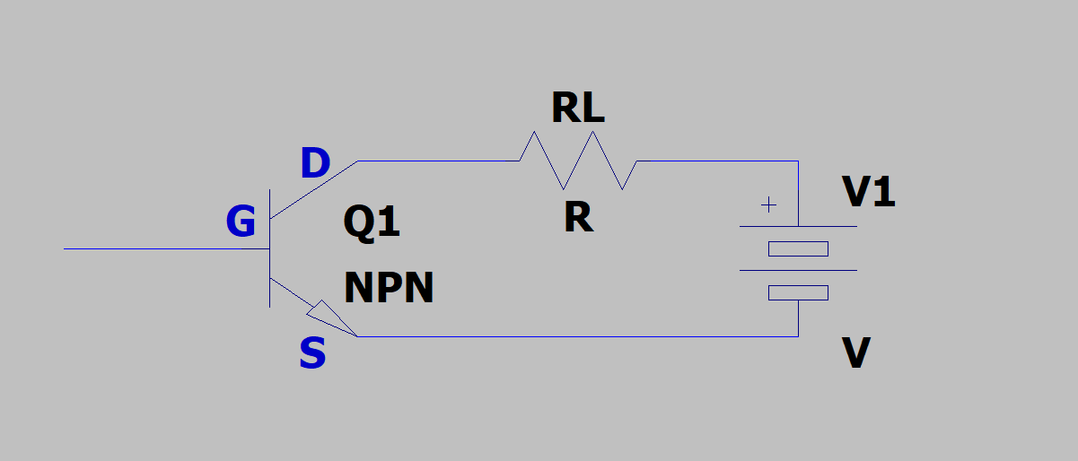

Figure 4. Circuit diagram showing the NPN transistor, the load resistance, and the battery.

The 5cm x 15cm heating pad in the prototype is intended for operation at 5V, but it can safely be operated at higher voltages [27]. Using a greater voltage will cause the pad to heat up quicker but will also discharge the battery faster – this is a potential trade-off that should be considered in future iterations of the device. At the suggested 5V operating voltage, the pad has an operating current of approximately 600mA which must be taken into account when selecting a battery pack for the armband [27]. Ideally, the device would last through an entire eight-hour working day at 100% duty, but this would require a battery with a large capacity and a bulky form factor which may inconvenience the wearer.

As the prototype was intended to be a proof-of-concept and only needed to operate for a few experiments and one demonstration, a standard 9V battery was used. However, a production quality iteration of the armband should not use such a battery as it would likely not have the capacity needed to power the components long enough to be useful to a worker needing this device.

**Conclusions and Future Directions**

Though the device prototype functioned as expected, numerous modifications could be made to refine it. For example, the material of the armband should be designed such that it is elastic enough to comfortably yet snugly fit various arm sizes while also being thick enough to adequately protect the components from the elements. Next, the algorithmic method of shiver detection should be made more effective by better utilizing the tremor frequency range of shivering instead of simply tracking rapid x-plane and/or y-plane motion to reduce the likelihood of the shiver condition becoming true when the wearer is not shivering. Another improvement that could be made is the optimization of power so that the armband will last throughout an entire working day without having to include a large battery that may impede the user’s ability to do their job.

One barrier for the proper function of the prototype is the inconsistent EMG measurements with the electrodes near the flexor digitorum muscle. This led to the electrodes being placed around the extensor digitorum instead, which is not ideal as the largest muscle in this area is responsible for finger extension which is opposite from the activity the device is intended to detect. To overcome this issue, the raw EMG signal from the sensor could be used along with a carefully designed analog front-end circuit to filter out the signals from muscles that are not of interest, allowing the evaluation of only the signals in the flexor digitorum.

Another key barrier to improving this device is balancing the heating pad warming strength and time against the capacity – and therefore physical size – of the battery pack. As heating elements draw a large amount of current, the battery selected for the device should ideally be able to power the circuit and the heating pad for a typical eight-hour working day (assuming a worst-case scenario where the heating pad would need to be turned on the entire day). One way to address this barrier would be to design the armband such that switching out a low battery with a fresh one is quickly and easily accomplished so the user could rely on the device even during exceptionally demanding days. Another option is to design a range of armband styles, with each style intended for different levels of duty with the primary difference being the capacity of the battery pack. It can be assumed that a person who will be working in conditions which require a greater use of the armband’s heat will be wearing bulky protective clothing and therefore would be less hindered by a large battery pack compared to someone who has on light clothes. Overall, the designed prototype laid solid groundwork for a concept which could make life easier for workers in extreme cold temperatures while potentially saving limbs and even lives.

**References**

[1] OSHA, “Wind Chill Temperature: A Guide for Employers” *osha.gov,* 2018. [Online]. Available: https://www.osha.gov/dts/weather/winter_weather/windchill.html#affected [Accessed Dec. 1, 2018].

[2] CCOHS, “Cold Environments – Working in the Cold” *ccohs.ca*, 2018. [Online]. Available: https://www.ccohs.ca/oshanswers/phys_agents/cold_working.html [Accessed Dec. 1, 2018].

[3] Y. Tochihara, et al. (2005, Feb.).“Work in Artificial Cold Environments*” Journal of Physiological Anthropology and Applied Human Science*, [Online]. 24(1), pp. 73-76. Available: https://www.jstage.jst.go.jp/article/jpa/24/1/24_1_73/_article/-char/en [Accessed Nov. 5, 2018].

[4] Y. Tochihara, et. al. (2007, Oct.). “Effects of repeated exposures to severely cold environments on thermal responses of humans” *Ergonomics*, [Online]. 38(5), pp. 987-995. Available: https://www.tandfonline.com/doi/abs/10.1080/00140139508925165 [Accessed Nov. 21, 2018].

[5] F. Chen, et. al. (1991). “A field study of cold effects among cold store workers in China” *Arctic Medical Research,* [Online]. 50(6), pp. 99-103. Available: https://www.ncbi.nlm.nih.gov/pubmed/1811590 [Accessed: Nov. 21, 2018].

[6] C. Bramham, et. al. (1998, Apr.). “Acute cold stress leading to elevated corticosterone neither enhances synaptic efficacy nor impairs LTP in the dentate gyrus of freely moving rats”, *Brain Research*, [Online]. 789(2), pp. 245-255. Available: https://www.sciencedirect.com/science/article/pii/S0006899397012651?via%3Dihub [Accessed: Nov. 22, 2018].

[7] S. B. Rutkove (2001, Jul.). “Effects of temperature on neuromuscular electrophysiology”, *Muscle Nerve*, [Online]. 24(7), pp. 867-882. Available: https://www.ncbi.nlm.nih.gov/pubmed/11410914 [Accessed: Dec. 1, 2018].

[8] K. Parsons (2002). *Human Thermal Environments*. (2nd ed.). [Online]. Available: http://soh.iums.ac.ir/uploads/0415237920_95689.pdf [Accessed: Nov. 29, 2018].

[9] Haman, F. (2006). “Shivering in the cold: from mechanisms of fuel selection to survival”, *Journal of Applied Physiology*, [Online] 100(5), p.1702. Available: https://www.physiology.org/doi/pdf/10.1152/japplphysiol.01088.2005 [Accessed Nov. 5, 2018]

[10] Amazon, “Volt Heated Work Gloves” *Amazon.com,* No Date. [Online]. Available: https://www.amazon.com/Volt-Heated-Work-Gloves-Rechargeable/dp/B019HKQOLW [Accessed Nov. 7, 2018].

[11] T. M. Mäkinen T.M. (2006). *Human Cold Exposure, Adaptation and Performance in a Northern Climate*. [Online]. Available: http://jultika.oulu.fi/files/isbn951428089X.pdf [Accessed: Nov. 2, 2018].

[12] F. Chen (1996). “Hand and finger skin temperatures in convective and contact cold exposure”, *Eur J Appl Physiol Occup Physiol.* [Online]. 72(4), pp. 372-379. Available: https://www.ncbi.nlm.nih.gov/pubmed/8851908 [Accessed: Nov. 14, 2018].

[13] R. S. Pozos, et al. (1987). “Human studies concerning thermal-induced shivering, postoperative Shivering, and cold-induced vasodilation”, *Annals of Emergency Medicine*. [Online]. 16(9), pp. 1037-1041. Available: https://www.ncbi.nlm.nih.gov/pubmed/3631668 [Accessed Nov. 20, 2018].

[14] F. Haman (2006). “Shivering in the Cold: From Mechanisms of fuel selection to survival”. *Journal of Applied Physiology*. [Online]. 100(5), pp. 1702-1708. Available: https://www.physiology.org/doi/full/10.1152/japplphysiol.01088.2005 [Accessed: Nov. 21, 2018].

[15] Sparkfun, “MyoWare Muscle Sensor” *Sparkfun.com,* No Date. [Online]. Available: https://www.sparkfun.com/products/13723 [Accessed Nov. 6, 2018].

[16] Arduino, “Arduino Nano” *Arduino.com,* No Date. [Online]. Available: https://store.arduino.cc/usa/arduino-nano [Accessed Nov. 2, 2018].

[17] Sparkfun, “Temperature Sensor – TMP36” *Sparkfun.com,* No Date. [Online]. Available: https://www.sparkfun.com/products/10988. [Accessed Dec. 1, 2018].

[18] Sparkfun, “SparkFun Triple Axis Accelerometer Breakout” *Sparkfun.com,* No Date. [Online]. Available: https://www.sparkfun.com/products/13963. [Accessed Oct. 31, 2018].

[19] K. T. Patton. *Anatomy & Physiology*. Mosby, 2016, pp. 216-217.

[20]  Sparkfun, “MyoWare Muscle Sensor” *Sparkfun.com,* No Date. [Online]. Available: https://www.sparkfun.com/products/13723 [Accessed Nov. 6, 2018].

[21] Sparkfun, “MyoWare Power Shield” *Sparkfun.com,* No Date. [Online]. Available: https://www.sparkfun.com/products/13684 [Accessed Nov. 8, 2018].

[22] Sparkfun, “Sensor Cable – Electrode Pads (3 connector)” *Sparkfun.com,* No Date. [Online]. Available: https://www.sparkfun.com/products/12970 [Accessed Nov. 6, 2018].

[23] Sparkfun, “Biomedical Sensor Pad (10 pack)” *Sparkfun.com,* No Date. [Online]. Available: https://www.sparkfun.com/products/12969 [Accessed Nov. 6, 2018].

[24] Sparkfun, “MyoWare Cable Shield” *Sparkfun.com,* No Date. [Online]. Available: https://www.sparkfun.com/products/14109 [Accessed Nov. 6, 2018].

[25] T. J. Roberts, et al. (2008). “Interpreting muscle function from EMG: Lessons learned from direct measurements of muscle force”, *Integrative and Comparative Biology*. [Online]. 48(2), pp. 312-320. Available: https://www.ncbi.nlm.nih.gov/pubmed/21669793 [Accessed: Nov. 14, 2018].

[26] C. J. De Luca (2002). “Surface Electromyography: Detection and Recording”. *DelSys.com,* 2002. [Online]. Available: https://www.delsys.com/Attachments_pdf/WP_SEMGintro.pdf [Accessed: Nov. 18, 2018].

[27] Sparkfun, “Heating Pad – 5x15cm” *Sparkfun.com,* No Date. [Online]. Available: https://www.sparkfun.com/products/11289 [Accessed Oct. 31, 2018].